**Export AWS EC2 as a VM to S3 Bucket**

**Note** : AWS User should have EC2,S3 & IAM full Access

Create a new bucket or use existing one

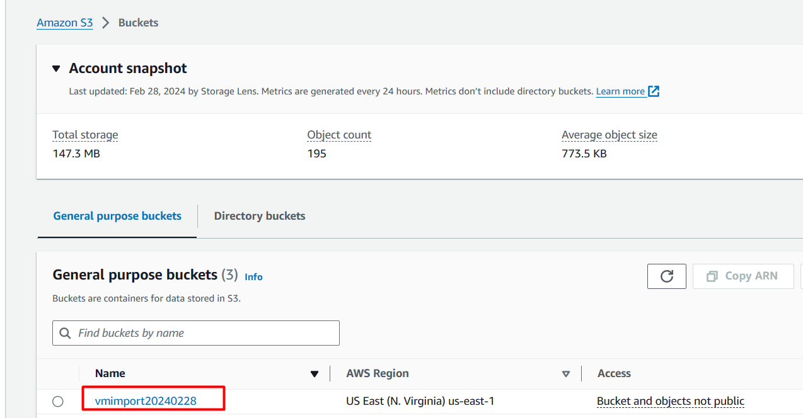

In S3 Bucket Permissions, Keep public access block = Off

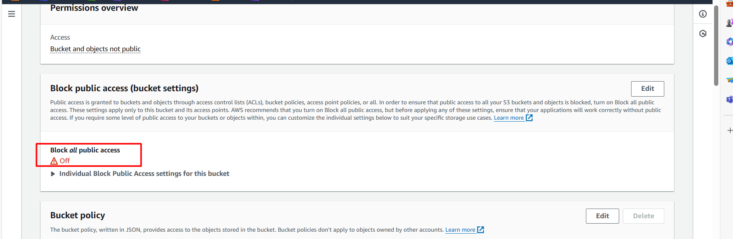

Bucket Policy of S3 Bucket

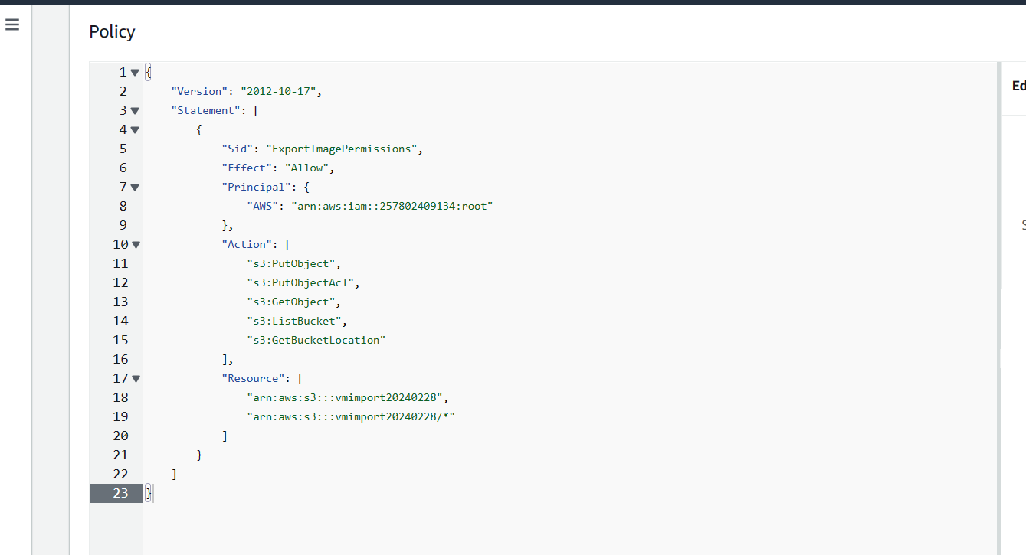

**{**

**"Version": "2012-10-17",**

**"Statement": [**

**{**

**"Sid": "ExportImagePermissions",**

**"Effect": "Allow",**

**"Principal": {**

**"AWS": "arn:aws:iam::257802409134:root"**

**},**

**"Action": [**

**"s3:PutObject",**

**"s3:PutObjectAcl",**

**"s3:GetObject",**

**"s3:ListBucket",**

**"s3:GetBucketLocation"**

**],**

**"Resource": [**

**"arn:aws:s3:::vmimport20240228",**

**"arn:aws:s3:::vmimport20240228/*"**

**]**

**}**

**]**

**}**

**If you are ROOT user:**  
  
{

"Version": "2012-10-17",

"Statement": [

{

"Sid": "ExportImagePermissions",

"Effect": "Allow",

"Principal": {

"AWS": "arn:aws:iam::YOUR_ACCOUNT_ID:root"

},

"Action": [

"s3:PutObject",

"s3:PutObjectAcl",

"s3:GetObject",

"s3:ListBucket",

"s3:GetBucketLocation"

],

"Resource": [

"arn:aws:s3:::grafana-test-llp",

"arn:aws:s3:::grafana-test-llp/*"

]

}

]

}

Enable S3 Bucket ACL & Give grantee permissions to ID based on your region

To find your region wise ID : https://docs.aws.amazon.com/vm-import/latest/userguide/vmexport.html

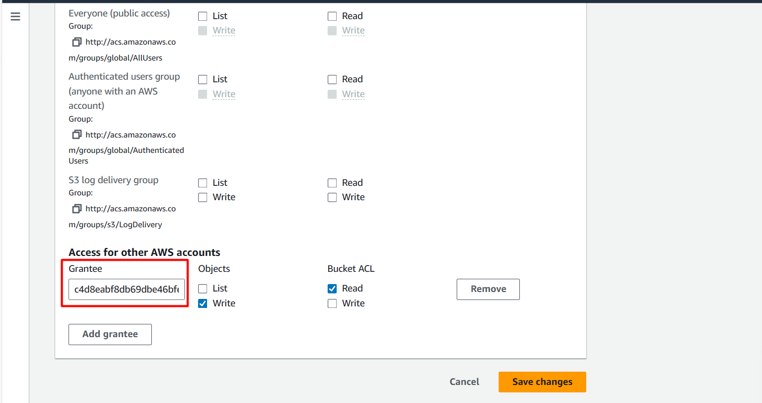

Now, In local configure AWS ClI

Create a file file.json

Replace S3 Bucket Name & S3 Prefix

**{**

**"ContainerFormat": "ova",**

**"DiskImageFormat": "VMDK",**

**"S3Bucket": "vmimport20240228",**

**"S3Prefix": "data/"**

**}**

aws ec2 create-instance-export-task --instance-id i-099db45fab26029f0 --target-environment vmware --export-to-s3-task <file://file.json>

Above will import instance as a VM in S3 Bucket in .OVA format.

Where, (i-099db45fab26029f0 is instance ID)

aws ec2 describe-export-tasks --export-task-ids export-i-079f9958d4ad4aa24

After completion of image import download image.ova in your local using AWS CLI

aws s3 cp s3://VMimport20240228/data/export.ova /home/ubuntu/Downloads

Extract image.ova

tar -xvf export.ova

Convert vmdk into qcow2 format

qemu-img convert -f vmdk -O qcow2 export-i-0cea6db51f225e1d8-disk-1.vmdk aws-test.qcow2